**Background**

Crowdfunding platforms like Kickstarter and Indiegogo have been growing in success and popularity since the late 2000s. From independent content creators to famous celebrities, more and more people are using crowdfunding to launch new products and generate buzz, but not every project has found success.

To receive funding, the project must meet or exceed an initial goal, so many organizations dedicate considerable resources looking through old projects in an attempt to discover “the trick” to finding success. For this week's Challenge, you will organize and analyze a database of 1,000 sample projects to uncover any hidden trends.

**Before You Begin**

1. Create a new space for this project called excel-challenge in either Dropbox or Google Drive. **Do not add this Challenge to an existing repository**.
2. Store your Excel workbooks here in this new space, and create a sharable link for submission.

**Files**

Download the following files to help you get started:

[Module 1 Challenge filesLinks to an external site.](https://static.bc-edx.com/data/dl-1-2/m1/lms/starter/Starter_Code.zip)

**Instructions**

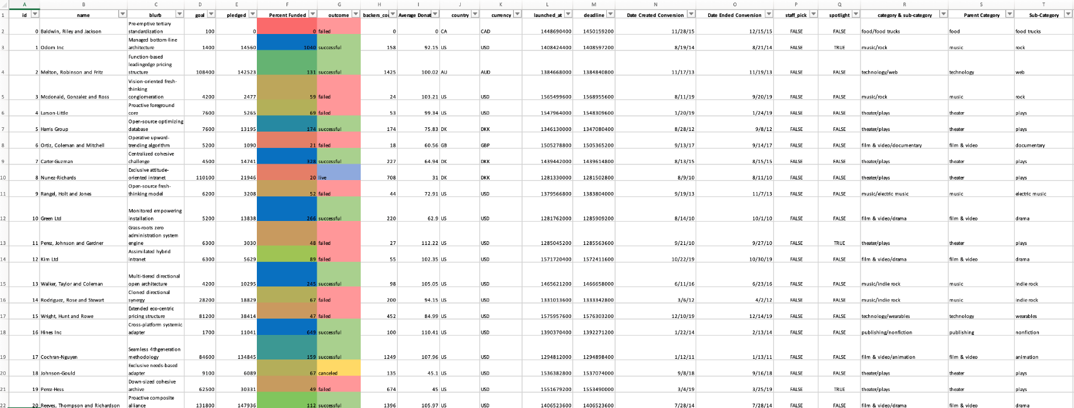

Using the Excel workbook in your .zip file, modify and analyze the sample-project data and try to uncover market trends.

* Data for this dataset was generated by edX Boot Camps LLC, and is intended for educational purposes only.
* Use conditional formatting to fill each cell in the outcome column with a different color, depending on whether the associated campaign was successful, failed, canceled, or is currently live.
  + Create a new column called Percent Funded that uses a formula to find how much money a campaign made relative to its initial funding goal.
* Use conditional formatting to fill each cell in the Percent Funded column according to a three-color scale. The scale should start at 0 with a dark shade of red, and it should transition to green at 100 and blue at 200.
  + Create a new column called Average Donation that uses a formula to find how much each project backer paid on average. =AVERAGE([@pledged]/[@[backers_count]])
  + Create two new columns, one called Parent Category and another called Sub-Category, that use formulas to split the Category and Sub-Category column into the two new, separate columns.
  + =LEFT(A2,SEARCH("/",A2)-1);
    - =LEFT([@[category & sub-category]],SEARCH("/",[@[category & sub-category]])-1)
  + =RIGHT(A2,LEN(A2)-SEARCH("/",A2))
    - =RIGHT([@[category & sub-category]],LEN([@[category & sub-category]])-SEARCH("/",[@[category & sub-category]]))

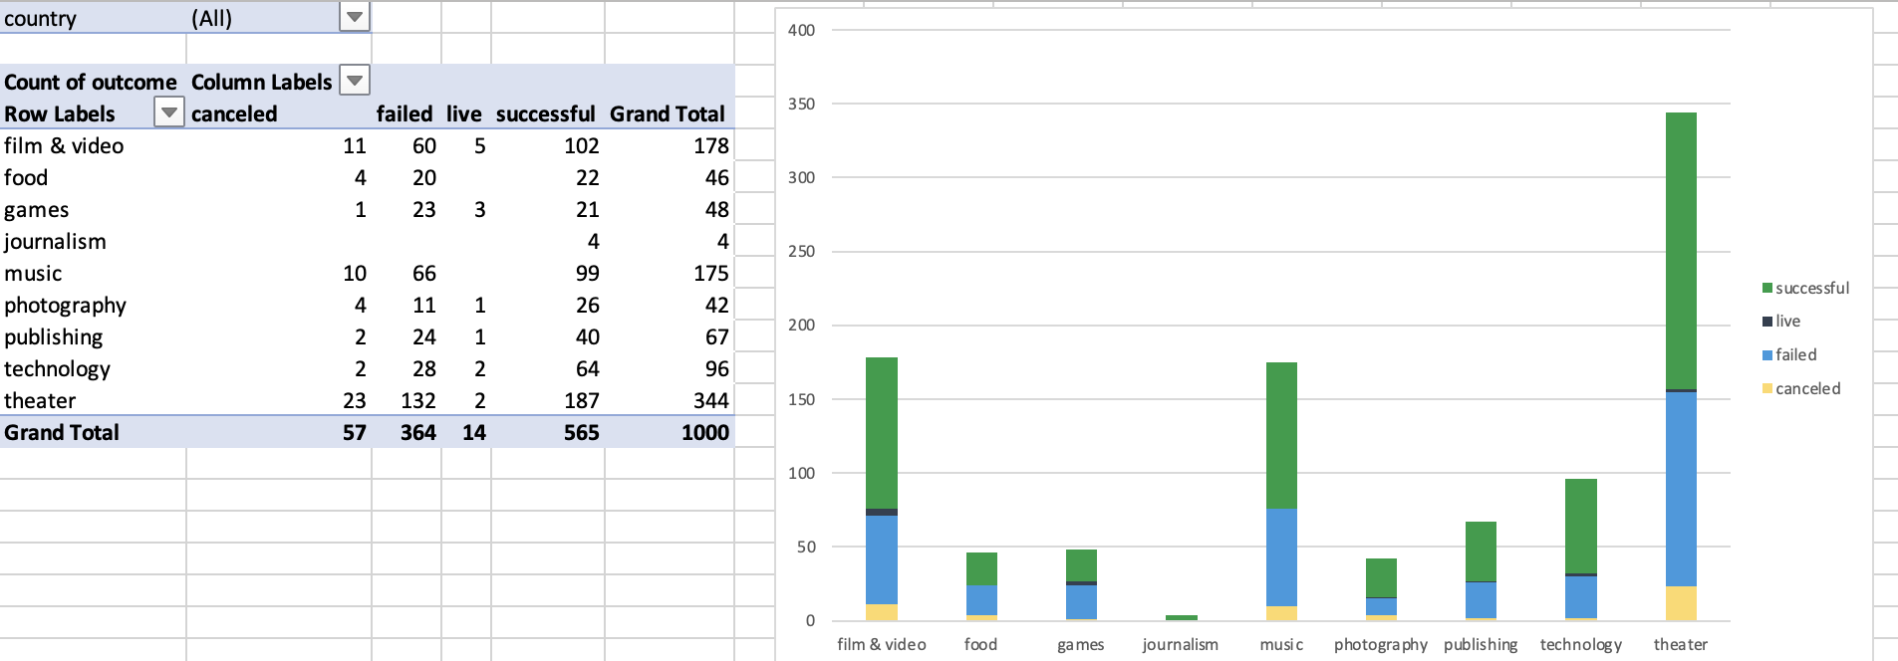

* + Create a new sheet with a pivot table that analyzes your initial worksheet to count how many campaigns were successful, failed, canceled, or are currently live per **category**.

* Create a stacked-column pivot chart that can be filtered by country based on the table that you created.

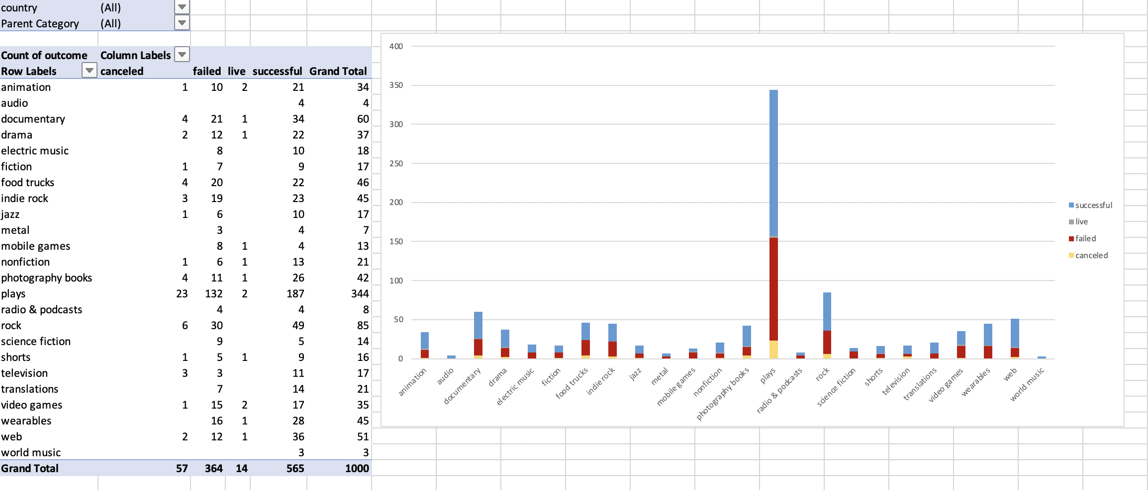

* Create a new sheet with a pivot table that analyzes your initial sheet to count how many campaigns were successful, failed, or canceled, or are currently live per **sub-category**.
* Create a stacked-column pivot chart that can be filtered by country and parent category based on the table that you created.
* Step 1 of 3 : Insert
* 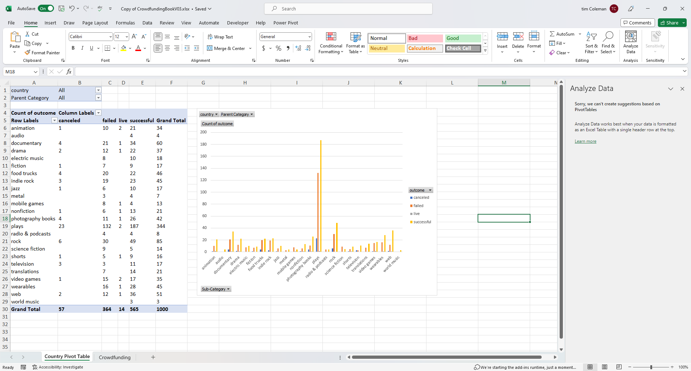
* Step 2 of 3 - PivotChart

Step 2

Not selectable

Step 3 of 3 – Select Column

Step 3 of 3

* The dates in the deadline and launched_at columns use Unix timestamps. Fortunately for us, [this formulaLinks to an external site.](https://www.extendoffice.com/documents/excel/2473-excel-timestamp-to-date.html) that can be used to convert these timestamps to a normal date.
  + Create a new column named Date Created Conversion that will use [this formulaLinks to an external site.](https://www.extendoffice.com/documents/excel/2473-excel-timestamp-to-date.html) to convert the data contained in launched_at into Excel's date format.
  + Create a new column named Date Ended Conversion that will use [this formulaLinks to an external site.](https://www.extendoffice.com/documents/excel/2473-excel-timestamp-to-date.html) to convert the data contained in deadline into Excel's date format.
  + =((([@deadline]/60)/60)/24)+DATE(1970,1,1)
  + =((([@[launched_at]]/60)/60)/24)+DATE(1970,1,1)

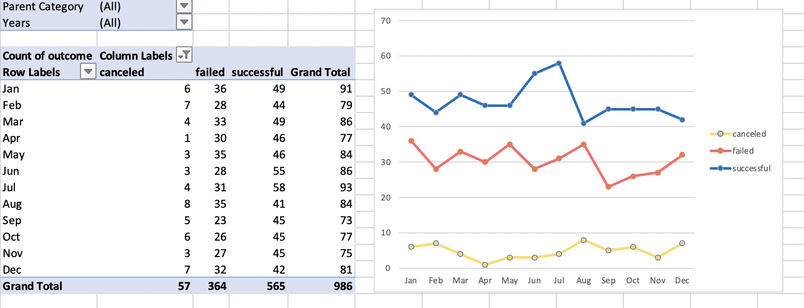

* + Create a new sheet with a pivot table that has a column of outcome, rows of Date Created Conversion, values based on the count of outcome, and filters based on parent category and Years.
  + =TEXT([@[Date Created Launch Conversion]],"MMMM")
  + =YEAR([@[Date Created Launch Conversion]])
  + Now, create a pivot-chart line graph that visualizes this new table.
* 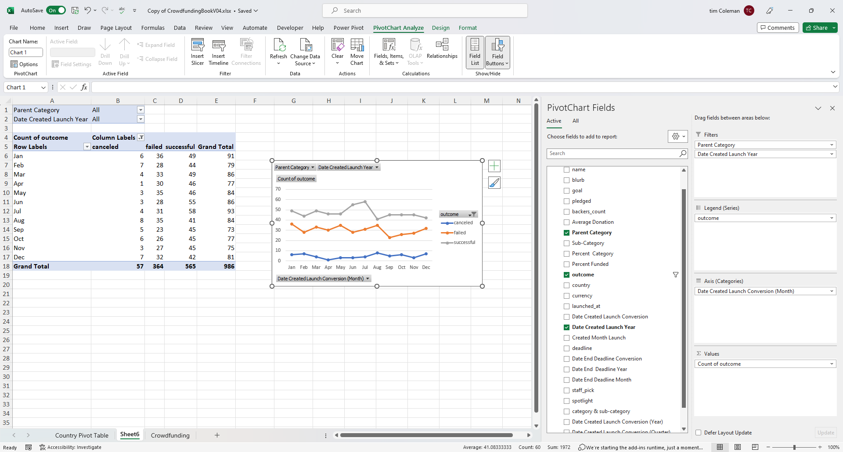
* Create a report in Microsoft Word, and answer the following questions:
  + Given the provided data, what are three conclusions that we can draw about crowdfunding campaigns?
  + What are some limitations of this dataset?
  + What are some other possible tables and/or graphs that we could create, and what additional value would they provide?

**Crowfunding Goal Analysis**

* Create a new sheet with 8 columns:
  + Goal
  + Number Successful
  + Number Failed
  + Number Canceled
  + Total Projects
  + Percentage Successful
  + Percentage Failed
  + Percentage Canceled
* In the Goal column, create 12 rows with the following headers:
  + Less than 1000
  + 1000 to 4999
  + 5000 to 9999
  + 10000 to 14999
  + 15000 to 19999
  + 20000 to 24999
  + 25000 to 29999
  + 30000 to 34999
  + 35000 to 39999
  + 40000 to 44999
  + 45000 to 49999
  + Greater than or equal to 50000

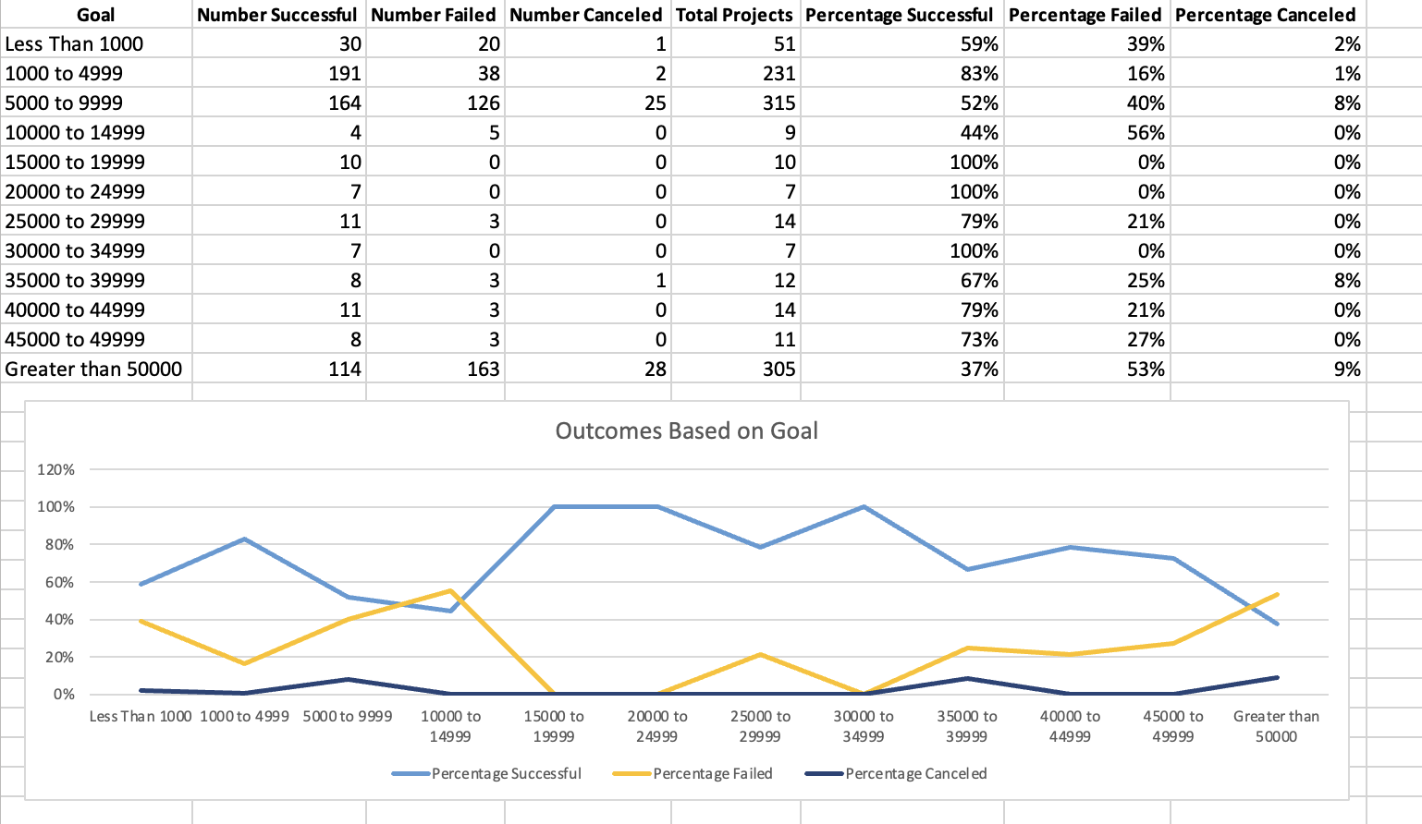

* Graphical user interface, application, table, Excel

  Description automatically generatedUsing the COUNTIFS() formula, count how many successful, failed, and canceled projects were created with goals within the ranges listed above. Populate the Number Successful, Number Failed, and Number Canceled columns with these data points.
  + =COUNTIFS(Crowdfunding!D7:D993,">4999",Crowdfunding!D7:D993,"<10000",Crowdfunding!L7:L993,"=failed")
  + =COUNTIFS(Crowdfunding!D6:D992,">999",Crowdfunding!D6:D992,"<5000",Crowdfunding!L6:L992,"=successful")
* Add up each of the values in the Number Successful, Number Failed, and Number Canceled columns to populate the Total Projects column. Then, using a mathematical formula, find the percentage of projects that were successful, failed, or canceled per goal range.
* Create a line chart that graphs the relationship between a goal amount and its chances of success, failure, or cancellation.

**Statistical Analysis**

Most people would use the number of campaign backers to assess the success of a crowdfunding campaign. Creating a summary statistics table is one of the most efficient ways that data scientists can characterize quantitative metrics, such as the number of campaign backers.

For gaining an in-depth understanding of campaign backers, evaluate the number of backers of successful and unsuccessful campaigns by creating **your own** summary statistics table.

* Create a new worksheet in your workbook, and create one column for the number of backers of successful campaigns and one column for unsuccessful campaigns.

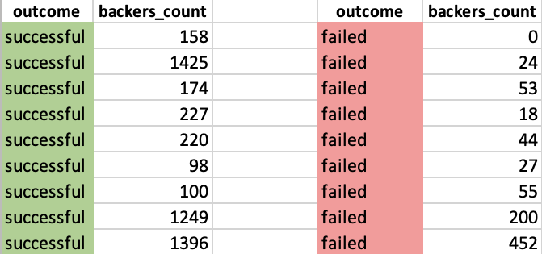

* Use Excel to evaluate the following values for successful campaigns, and then do the same for unsuccessful campaigns:

* + The mean number of backers
    - =AVERAGE (B2:B10)
  + The median number of backers
    - =MEDIAN(B2:B10)
  + The minimum number of backers
    - =MIN(B2:B10)
  + The maximum number of backers
    - =MAX(B2:B10)
  + The variance of the number of backers
    - =STDEV.P(B2:B11)
  + The standard deviation of the number of backers
* Use your data to determine whether the mean or the median better summarizes the data.
* Use your data to determine if there is more variability with successful or unsuccessful campaigns. Does this make sense? Why or why not?

**Submission**

To submit your Challenge assignment, click Submit, and then provide the URL of your GitHub repository for grading.

**NOTE**

You are allowed to miss up to two Challenge assignments and still earn your certificate. If you complete all Challenge assignments, your lowest two grades will be dropped. If you wish to skip this assignment, click Next, and move on to the next Module.

Comments are disabled for graded submissions in BootCamp Spot. If you have questions about your feedback, please notify your instructional staff or your Student Success Manager. If you would like to resubmit your work for an additional review, you can use the Resubmit Assignment button to upload new links. You may resubmit up to three times for a total of four submissions.

**IMPORTANT**

No matter how difficult the course becomes, you must always turn in original work. Plagiarism is not tolerated. If your instructional or support staff determine that you have plagiarized work, your Student Success Manager will determine the appropriate course of action based on university policy. Such actions may include, but are not limited to, a documented plagiarism discussion, an incomplete or failing grade assignment, or ineligibility for graduation.

**It is your responsibility to include a note in the README section of your repo specifying code source and its location within your repo**. This applies if you have worked with a peer on an assignment, used code in which you did not author or create sourced from a forum such as Stack Overflow, or you received code outside curriculum content from support staff such as an Instructor, TA, Tutor, or Learning Assistant. This will provide visibility to grading staff of your circumstance in order to avoid flagging your work as plagiarized.

**References**

Data for this dataset was generated by edX Boot Camps LLC, and is intended for educational purposes only.

[Previous](https://courses.bootcampspot.com/courses/3796/modules/items/1011488)[Next](https://courses.bootcampspot.com/courses/3796/modules/items/1011490)

© 2023 edX B